VETOQUINOL BV
STANDARD CONDITIONS OF SALES

PRELIMINARY : DEFINITIONS

The terms used shall have the following meanings :

The “Seller” means VETOQUINOL BV,

The “Purchaser” means the party to whom Products are supplied subject to these Conditions.

“Conditions” means the standard terms and conditions of sale set out in this document. These Conditions are accepted by the Purchaser when placing the order. The Seller reserves the right to modify the Conditions at any time.

"Products" means the ranges of products specified in the price list as issued by the Seller and as updated from time to time in accordance with these Conditions and all products covered by an order.

"Intellectual Property" means the trademarks and trade names, copyrights, formulae, packages and designs owned or registered or used by the Seller.

1.ORDERING

  - The Purchaser shall follow the Seller’s order process as described below. For questions the seller can contact customer service : info.nl@vetoquinol.com
  - verzonden op donderdag 12 december 2024 11:32

  - All purchase orders (PO) should be sent to orders.nl@vetoquinol.com.Orders sent by telephone cannot be accepted. Following receipt of an order, if the Seller provides an order acknowledgement containing an order number, this order acknowledgement is only to confirm that the order has been received and shall not constitute acceptance of the order by the Seller.
  - The Seller requires all PO to contain the following information:
    - A PO Reference/Number
    - The delivery adress
    - The invoice adress
    - The Product description
    - The Seller’s Product code
    - The required quantity shall be in line with the format quoted on VETOQUINOL Price List
    - Booking In details should be provided on the PO if a booking is required to make delivery.

  - The Seller may accept or decline an order in whole or in part at its absolute discretion.
  - In the event that the order is cancelled by the Purchaser, the Purchaser shall agree to pay for any associated transportation & processing charges relating to the cancelled order, if incurred by the Seller.
  - The Purchaser and the Seller have the right to request cancellation of any order of Products placed with the Seller prior to delivery with prior mutual agreement.
  - The Seller can be reached from Monday to Friday 09:00 h -12:30 h and 13:00 h-17:00 h for any placement of orders. Orders received after 13: 00 h will be processed the following working day and the lead time will apply from the time the order is processed.
  - All Orders must comply with VETOQUINOL Standard packaging and/or multiples. Standard packaging are subject to change at any time by the Seller.

2. DELIVERY

2.1. All Products will be supplied by the Seller on a DDP basis as defined in Incoterms 2020.
2.2. The Seller will use reasonable endeavors to deliver the Products by the date confirmed by the Seller to the Purchaser that is only an estimation.
2.3. Unless otherwise agreed, delivery of orders must be to the delivery point specified in the order and received by an authorized representative of the Purchaser.
2.4. Each shipment of Products will be deemed to have been accepted by the Purchaser unless the Purchaser reports any damage or shortfall (other than hidden defects) on the delivery note at time of delivery. Unless so notified, the quantity on order of any Products as recorded by the Seller on the delivery note at time of dispatch shall be conclusive evidence of the quantity received by the Purchaser unless the Purchaser advise of any discrepancy at the time of delivery and sign the Proof of Delivery (POD) accordingly.
2.5. The Seller will not accept any liability or claim regarding delivery discrepancies that are notified after the time of delivery and not recorded on POD unless subsequent investigations by the Seller are able to conclude and support any claim or discrepancy raised by the Purchaser.
2.6 Any liability of the Seller shall be limited to replacing the Products within a reasonable time and in line with the purchaser normal order pattern, or issuing a credit note against any invoice raised for such Products.

3.PRICES AND PAYMENT

3.1. The Seller may modify the prices of the Products at any time and will consider to give reasonable notice of any price changes where possible. Products are invoiced and sold at the prices and conditions in force on the day the order is received by the Seller. For each delivery, an invoice is issued.
3.2. Unless otherwise agreed the prices shall include delivery to the Purchaser’s premises and are exclusive of any VAT.
3.3. The Purchaser will pay for all Products delivered and invoiced within 30 days from invoice date.
3.4. The Seller reserves the right to charge, with interest on any sums outstanding after they shall become due.

4. RISK AND TITLE

4.1. Risk in the Products shall pass to the Purchaser on delivery.
4.2. Ownership of the Products shall not pass to the Purchaser until the Seller has received in full all sums due to it in respect of the Products and all other sums which are, or which become due to the Seller from the Purchaser on any account (including any applicable delivery charges).
4.3. Until ownership of the Products has passed to the Purchaser, the Purchaser must not alter or make any addition to the labelling or packaging of the Products displaying the Product trademarks, or not destroy, deface or obscure any identifying mark or packaging on or relating to the Products, unless specifically agreed in writing with the Seller.
4.4. The Purchaser must maintain the Products in satisfactory condition in compliance with the Good Distribution Practices and insure the Products for their full price against all risks. On request, the Purchaser shall produce the policy of insurance to the Seller.
4.5. The Purchaser may resell the Products before ownership has passed in the ordinary course of the business.
4.6. The Purchaser shall grant the Seller, its agents and employees an irrevocable right at any time but on reasonable notice and during business hours to enter any premises where Products that have not been paid are stored, in order to inspect them, or, where the Purchaser’s right to possession has terminated, to recover them.

5. INTELLECTUAL PROPERTY RIGHTS

The Purchaser hereby acknowledges that the Intellectual Property relating to the Products is the sole and exclusive property of the Seller and any purchase of Products does not confer on the Purchaser any rights relating thereto.

6.RETURN POLICY
6.1. All returns should respect the Seller‘s returns, claims and credits procedure outlined in Annex A.
6.2. Returns will not be accepted unless previously agreed with the Seller for the strictly limitative reasons:
-The Products are not in conformity with the order.
-The Products are damaged during transport, for which a specific reservation has been made on the transport document and on the carrier’s, delivery note before the Products are delivered for,
-The Product are delivered with an expiry date of less than 6 months and the Seller did not notified the Purchaser of the short date in advance of delivery, if not subject to special discounts and/or not pre-authorized by the Purchaser.
-The Seller and the Purchaser made a mutual agreement to supply the Product on a sale or return basis.
For any return, the Seller will issue a return reference number.
6.3.A credit note will not be issued by the Seller for any return that is deemed unauthorized.
6.4.The Purchaser is responsible for any delivery charges in relation to returns including sensitive Products like Narcotics/Psychotropics. Purchasers should have the ability to destroy Products as required in line with appropriate legislative regulations and guidelines.
6.5. Returns that are agreed between the Seller and the Purchaser will be uplifted within 30 days from the date of that agreement and credit raised within 30 days from the date the Product is returned to the Seller’s warehouse.
6.6.Retuns of expired Products will never be accepted by the Seller, neither returns of Products in open primary packaging (bottle, jerry can, bag, etc.).These Products should be destroyed and disposed of in accordance to legislation or regulations and guidelines at cost to the Purchaser.
6.7.The Seller will raise a credit note for any expired Product held by the Purchaser and agreed for credit with the Seller (subject to the above conditions in 6.2.)upon the Purchaser being able to show documented proof of destruction.

7.FORCE MAJEURE

The Seller reserves the right to defer the date of delivery or to cancel any order placed by the Purchaser or reduce the volume of the Products ordered by the Purchaser (without liability to the Purchaser) if it is prevented from or delayed in the carrying on of its business due to circumstances beyond the reasonable control of the Seller including, without limitation, acts of God, governmental actions, war or national emergency, riot, civil commotion, fire, explosion, flood, pandemics and epidemics, lock-outs, strikes or other labor disputes (whether or not relating to either party's workforce), or restraints or delays affecting carriers or inability or delay in obtaining supplies of adequate or suitable materials provided that, if the event in question continues for a significant continuous period, the Purchaser shall be entitled to give notice in writing to the Seller to cancel the order / delivery .

8. LIABILITY

8.1. Nothing in this Conditions shall limit or exclude any liability which cannot legally be limited or excluded including but not limited to liability for:
(a) death or personal injury caused by negligence; or
(b) fraud or fraudulent misrepresentation.
8.2 Subject to Clause 8.1:
(a) the Seller will not be liable to the Purchaser for any loss of profit, or any indirect or consequential loss arising under or in connection with these Conditions;
(b) the total aggregate liability of the Seller shall in no circumstances exceed the price of the Products paid or to be paid.

8.3. The Seller gives no warranty or representation, express or implied (including any implied warranties or merchantability and fitness for any particular purpose) regarding the condition or suitability of the Products.

9.JURISDICTION

The Conditions shall be governed by, construed and interpreted in accordance with the laws of The Netherlands. Any dispute which may arise between the Parties out of, in relation to, in connection with the Conditions or, any breach thereof, which cannot be settled amicably, shall be brought before the courts of The Netherlands.

10.ANTI CORRUPTION

The Purchaser:
- acknowledges it has received a copy of the Anti-corruption Code of Conduct issued by Seller (“Code of Conduct”) and/or has searched such Code of Conduct available on Seller’s website at: https://www.vetoquinol.com/eng/content/ethics-and-anti-corruption;
- declares and warrants that it has read the aforementioned Code of Conduct and has presented or provided the content of such Code of Conduct to those of its employees, agents, representatives and/or consultants (the “Representatives”)
- and its Representatives, will at all times, abide by (i) the terms stated in the Code of Conduct, (ii) the principles of Sapin II Law (French law targeting transparency, anti-corruption and the modernization of the economy) and/or (iii) the provisions and/or principles of any other similar law or regulation in any relevant country (items (i), (ii) and (iii) collectively referred to as “Anti-Corruption Principles”).
Any behaviour suggesting a breach or violation of this Article 10 may result, at the Seller's option, in the cancellation of any order for Products and the termination of any obligation of the Seller, without its liability being engaged and without prejudice to any other rights or remedies to which the Seller may be entitled.

11. PHARMACOVIGILANCE

The Purchaser will comply with local and European regulations concerning their pharmacovigilance obligations.
The Purchaser shall inform VETOQUINOL Pharmacovigilance Department (contact information in Annex B) of any adverse reaction in human and animals as well as any suspicion of lack of efficacy, any report of suspicion of non-validity of withdrawal period (meaning the detection of an active substance or a marker residue in foodstuff from an animal treated in amount above the Maximum Residue Limit after application of the approved withdrawal period), any potential environmental problems or suspected transmission of an infectious agent which are observed after use of the Products. The Purchaser shall inform VETOQUINOL immediately, and no later than one working day.

12. INSOLVENCY

If the Seller, acting reasonably, has reason to believe the Purchaser has or will become insolvent or bankrupt (as the case may be) or ceases, or threatens to cease, to carry on business, then without prejudice to any other right or remedy available to the Seller, the Seller shall be entitled to cancel any order or suspend any further deliveries without any liability to the Purchaser.

13. DATA PROTECTION

The Seller and the Purchaser each agree to comply with their obligations under all applicable data protection and privacy legislation including the General Data Protection Regulation (the GDPR (EU) 2016/679) with respect to the processing of personal data under or in connection with these Conditions.
If a party receives any complaint, notice or communication which relates to any actual or alleged non-compliance with data protection law with respect to the processing of personal data under or in connection with these Conditions, that party shall without undue delay notify the other party in writing and the parties shall cooperate with one another to resolve the same.

Annex A: Vetoquinol returns, claims and credits procedure

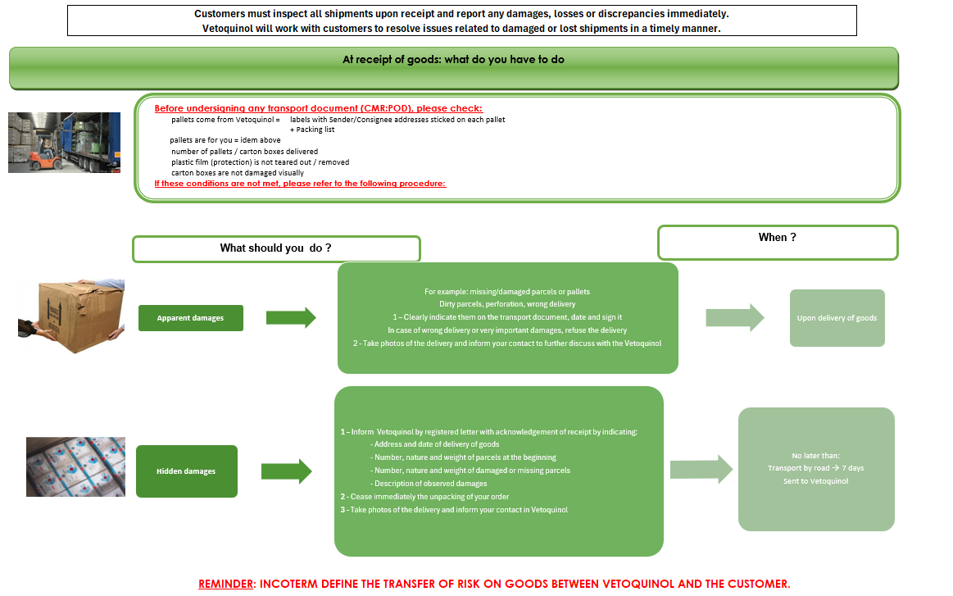

annex b: CONTACT INFORMATION

VETOQUINOL Global Pharmacovigilance :

- E-mail address for individual adverse event reports/general queries/queries requiring urgent response:

pharmacovigilance@vetoquinol.com

- Qualified persons for Pharmacovigilance VETOQUINOL Group

Name/Title: Dr. Vet Corinne Tzanavaris,
Director Pharmacovigilance Group, QPPV
Phone : +33 3 84 62 56 12
Phone : +33 6 73 68 47 41
E-mail : corinne.tzanavaris@vetoquinol.com
Address : 34 Rue du Chêne Sainte-Anne,
Magny-Vernois,
70200 LURE (France)

Name/Title: Dr Vet Emilie Devillers,
Pharmacovigilance Risk Manager Group, QPPV deputy
Phone: +33 3 84 62 59 72
Phone: +33 6 84 76 97 18
E-mail: emilie.devillers@vetoquinol.com
Address : 34 Rue du Chêne Sainte-Anne,
Magny-Vernois,
70200 LURE (France)

VETOQUINOL Local Pharmacovigilance (if applicable):

- Local or Regional Responsible person

Name/Title: Jeroen Lievens
Regulatory Affairs & Quality Manager Benesca

E-mail : Jeroen.lievens@vetoquinol.com

